GOVERNMENT POLYTECHNIC, SOLAPUR



**A**

**Project Report**

**On**

**Content Management System**

**Submitted by**

**Ms. Pogul Pooja Govardhan**

**Ms. Yemul Priyanka Ambadas**

**Ms. Maile Ashwini Nagnath**

**Ms. Rasmal Monika Laxminarayan**

**Ms. Ransure Prajakta Bapu**

Diploma(Computer Technology)

**Under the Guidance**

**Of**

**Prof. Ravindra Y. Gangundi sir**

**In Partial Fulfillment of Diploma**

**Department of Computer Technology,**

**MSBTE**

**2014-15**



**CERTIFICATE**

This is to certify that,

Ms. Pogul Pooja Govardhan

Ms. Yemul Priyanka Ambadas

Ms. Maile Ashwini Nagnath

Ms. Rasmal Monika Laxminarayan

Ms. Ransure Prajakta Bapu

from Diploma in Engineering (Computer Technology) have completed Project Design work on “**Content Management System**” as a partial fulfillment of Diploma in Engineering degree requirement in Computer Technology, MSBTE in academic year 2014-15 .

**Guide HOD Principal**

(Prof. R.Y.Gangundi) (Prof. R.Y.Gangundi) (Smt.S.D.Deshapande)

Date:

Place:Solapur

ACKNOWLEDGEMENT

It gives us a great pleasure in presenting the project report of **“Content Management System”**.

We express our deep sense of gratitude and thanks to our esteemed guide**. Prof. R.Y.Gangundi** for the valuable guidance that he has given to us for the completion of the project. We are indebted to her for guidance and encouragement, which made it possible for us to complete this project.

We sincerely thank our Head of The Department**. Prof.R.Y.Gangundi** for his support and encouragement for this project. So we were able to complete the project in an easy manner.

We would also like to thank our Principal **Smt.S.D.Deshpande** for providing all necessary facility to complete our project.

We also express our regard to the other teaching and non-teaching staff of the department who all has supported us.

At last we thankful to all those who have directly or indirectly helped us in completing the project.

INDEX

|  |  |  |
| --- | --- | --- |
| Sr. no. | Chapter Name | Page no. |
| 1 | Introduction to CMS | 6 |
| 2 | Introduction to Joomla! | 11 |
| 3 | Analysis | 18 |
| 4 | Design | 20 |
| 5 | Testing and Test Cases | 27 |
| 6 | Conclusion | 33 |
| 7 | References | 35 |

ABSTRACT

The static website is read-only to the users. The user can’t change or update the website as required. They can’t be understandable by the non-technical persons. For developing static website it takes too much time. The requirements must be specified in the beginning stage and it must be clear. The time to time changes not possible.

The end user should require complete knowledge about their website, to do any changes. If they want any changes they must meet the developer to any changes. The performance of static website becomes poor as time passes. If we want to change any contents after hosting, then we have to change in our backup files . After that modified file should be uploaded again and override exiting files.

To resolve this problem, we make our website dynamic. Due to dynamic website, it is understandable by users and non-technical person. The time to time changes are possible by this kind of website. The performance and efficiency of this website is good as compared to static website.

Chapter 1

Introduction To CMS

OBJECTIVES

* + Provide security, governance and approval processes over content published on the web.
  + Enable the creation, management, and usage of standardised metadata.
  + Continue to support a diverse array of existing technology platforms.
  + Consolidate the current technology environment wherever possible.
  + Improve the quality of Monash web sites through the implementation of standards across presentation, metadata, governance, discovery, and navigation.
  + To provide dynamism to the website.
  + To minimize development time.
  + To provide facility to change or update the content within the website.

Content Management System :

The University Web Content Management System (CMS) is a sophisticated tool for building, managing and maintaining University template-based websites through a single web-based interface. In the CMS you can easily create and edit web content using 'edit-on Pro', a Word- like web editor built into the CMS interface.

Some of the CMS features and benefits include:

* Easy-to-use interface for non-technical staff
* Easy content publishing via a Word-like WYSIWYG editor
* Flexible workflow management to ensure quality control
* Flexible user rights and roles to control access to relevant areas of the website
* Easy to enforce template and consistent look and feel
* Built-in web accessibility and standards compliance

To maintain a [profit](http://en.wikipedia.org/wiki/Profit_(accounting)), supermarkets make up for the lower margins by a higher overall volume of sales, and with the sale of higher-margin items bought by the intended higher volume of shoppers. Customers usually shop by placing their selected merchandise into [shopping carts](http://en.wikipedia.org/wiki/Shopping_cart) (trolleys) or baskets (self-service) and pay for the merchandise at the [check-out](http://en.wikipedia.org/wiki/Point_of_sale).

Workflow of CMS

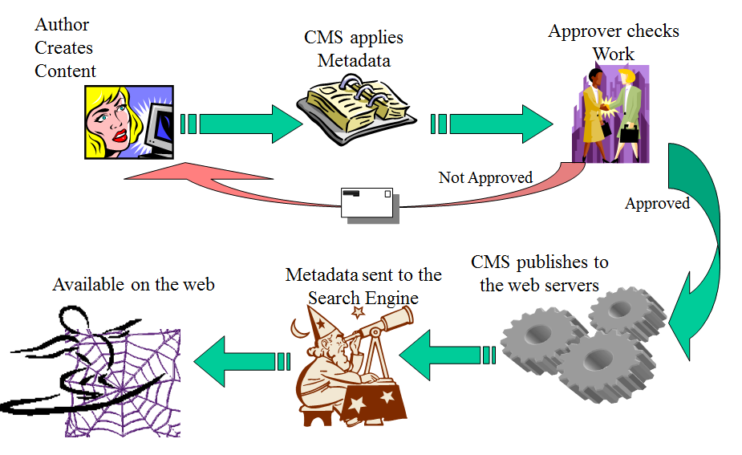

Top 10 Open Source CMS:

* WordPress
* Joomla
* Drupal
* Media Wiki
* Plone
* Liferay
* TYPO3
* Moodle
* Dolphin
* Pligg

Advantages of CMS:

* Can facilitate sharing of content across multiple Web sites
* Can make it easier for non-technical staff to update content
* Forces a formal workflow management and publishing process
* Can improve consistency of look and feel
* Allows web page updates using an ordinary web browser (e.g. IE, Firefox, Safari, Mozilla etc.)
* Reduces overall work as those responsible for content can update it directly and submit it for approval
* Allows different access levels for individuals with different roles (e.g. Authors, Editors, Managers)
* Enables documents to be published for fixed terms; older versions of documents can be re-used (versioning)
* Especially good for simple content pages.

Disadvantages of CMS:

* Does not write content!
* Does not create site structure – needs planning
* Is not a design tool
* Does not create images
* Does not automatically link pages in to a site and make them visible
* It is not fully WYSIWYG (What You See Is What You Get)

Chapter 2

Introduction to JOOMLA!

Why Joomla?

* Joomla is a free, open source content management system
* Organizes all forms of content
* It helps you to create/edit/delete content in a shared database
* Content shared across the Web site
* Content can be published or not - based on conditions (Approved, Date range, Viewer rights)
* Easy to use and expandable
* Originated in 2000 as Mambo, Split in 2005 to form Joomla
* The name Joomla is a phonetic spelling for the Swahili word "Jumla", which means "all together" or "as a whole".
* An award-winning content management system (CMS)
* Open Source software
* Available for Linux and Windows.

What Joomla!can do ? Some real examples

* Corporate Web sites or portals
* Online magazines, newspapers, and publications
* E-commerce and online reservations
* Government applications
* Small business Web sites
* Non-profit and organizational Web sites
* Community-based portals
* School Web sites
* Personal or family homepages

|  |  |
| --- | --- |
| Basic Structure of Joomla:    Front End:   * Viewable by users. * It is our actual website from which users can view information of Institute.   Back-end:   * Editable by administrator. * It is that from which the administrator can manage the contents of the website.   Database:   * Stores information such as faculty, departments, contacts etc. * It doesn’t stores images and documents.   Joomla CMS Architecture    Database :  All your content except image files and documents are stored in database  Joomla Framework:  It is collection of open source software that the Joomla! CMS is built on.  Templates, components, Modules, Plugins :  These are referred to as Extensions. They extends the base joomla! framework.  Components:  Components can be thought of as mini application and are what you will interact with most.  Modules:  Modules are lightweight extensions used in page rendering. They can stand on their own or be used to display data from component .Modules are managed from “Module Manager”.  Plug-ins:  Plug-ins are bit of code that execute at specific event triggers. They are wonderful way of extending Joomla! Framework.  Templates:  Templates determine the look and feel of our website.    Advantages of Joomla!   * Open source- The best advantage of using the Joomla CMS is that it is an open source platform and is available for free. All the source codes are available for free and the user can reuse it as per the requirements. * Usability- Joomla CMS can be used for making any kind of websites, right from the small, simple and personal blog to the large corporate website or any e-commerce website. The plenty of options and features available in Joomla CMS enables the user to make a website with all necessary modules. * Accessibility- Joomla Content Management System is very easy to use and even a layman having no technical knowledge about HTML programming can make a website using it. This is one of the major advantages of Joomla CMS which is making it increasingly popular bit by bit. * Themes and templates- Joomla CMS comes with various attractive themes and templates. You can make your website look attractive by using different inbuilt templates and themes. You can select the theme and template which goes well with your niche and topic. Selecting or changing the existing theme and template is absolutely easy in Joomla CMS. * Trouble-free Migration -If you have your website in Joomla you can migrate to any other server with ease. * Customer Support- Joomla CMS is run by a vast community and if you are facing any technical problem in maintaining your website in Joomla you can submit a report or a bug and your problem will be fixed in real time b the experienced and large community of Joomla.     Disadvantages of Joomla:   * One major drawback that Joomla user experience is that some of its plug-ins works with only some particular scripts. * You can customize your website extensively as you can do with other open source platforms. * The learning curve is larger as compared to other open source platforms. * Makes the website heavy to load and run.   Chapter 3  Requirement Analysis  Requirement Analysis  Requirement Analysis bridges the gap between System Engineering and Software Design. Requirement analysis is the most important task in software development Life Cycle.  User Requirements   * Website should be Easy to handle ,user friendly, interactive etc. * Institute information should be stored properly. * Allow the Faculty and administrator to select login type. * Allow for Administrator to Check Login details. * Allow to Faculty for easily update the Institute details. * Support to maintain the Login details.   Software Requirements  Operating system : Windows OS  Application software : XAMPP, Joomla 3.x.  Browsers : Google chrome, Mozilla Firefox, Internet Explorer etc.  Chapter 4  Design  DIAGRAMS  Data Flow Diagram:  C:\Users\abcd\Desktop\Diagrams\dfd.png |  |
|  |  |

Entity Relationship Diagram**:**

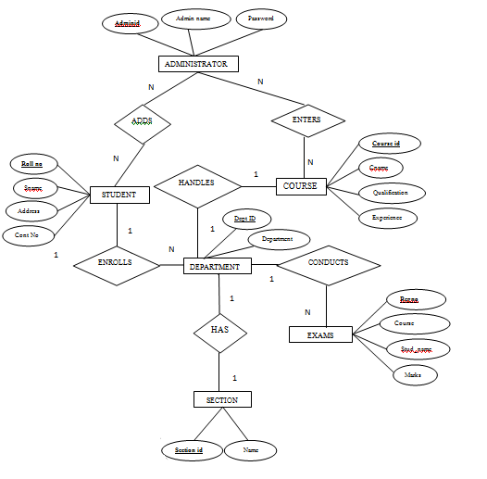

UML DIAGRAMS

Use case diagrams

For Login Page

**LOGIN**

**UPDATE**

**LOGOUT**

Admin

For Home Page:

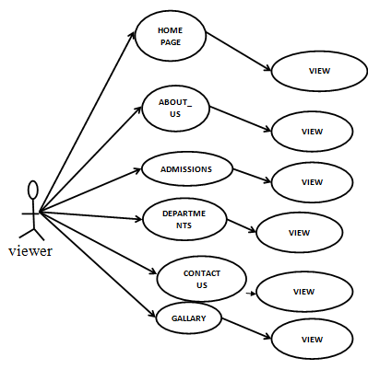

Activity diagram

For Administration

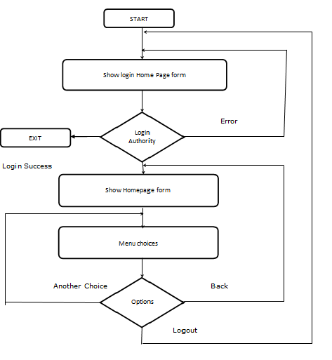

Front End Screenshot:

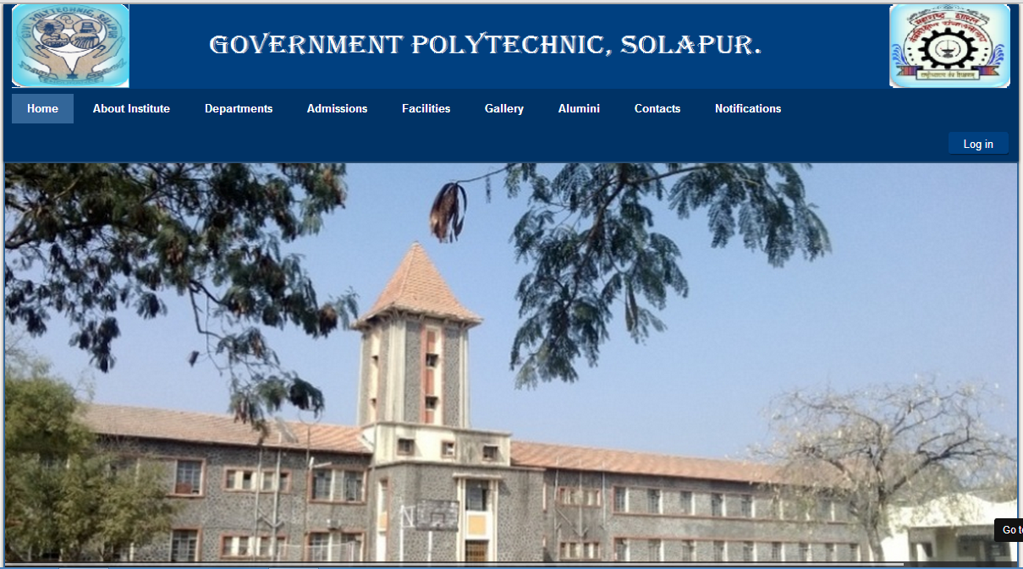

Chapter 5

Testing and Test Cases

Software Testing Strategy:

The software engineering process may be viewed as a spiral; system engineering defines the role of software and leads to software requirement analysis, where the information domain, function, behavior, performance, constraints, and validation criteria for software are established. Moving inward along the spiral, we come to design and finally to coding. To develop computer software, we spiral inward along streamlines that decrease the level of abstraction on each turn.

A strategy for software testing may also be viewed in the context of the spiral. Unit testing begins at the vortex of the spiral and concentrates on each unit (i.e. component) of the software as implemented in source code. Testing progresses by moving outward on the spiral testing to integration testing. The focus is on design and construction of application architecture

Test Case:

Test case is documentation which includes input values, expected output and status of that test. The main objective of test cases is to check whether the software meet the business and user requirements.

For our website, there are two parts:

* + 1. Front end i.e. Homepage.
    2. Back end i.e. Administrator site.

Test Cases for “Administrator site”:

|  |  |  |  |  |  |  |  |
| --- | --- | --- | --- | --- | --- | --- | --- |
| **TC-ID** | **Test**  **case**  **Objectives** | **Prerequi-site** | **Steps** | **Input**  **Data** | **Expected result** | **Actual result** | **Status** |
|  |  |  |  |  |  |  |  |
| TC-1 | To check username | Login page must be opened and username text field must be enabled. | Enter username with combination of alphabets and digits at least 1 character. | Text as input  (e.g. user) | It should prompt “username is correct”. | It prompts “Username is correct”. | Pass |
| TC-2 | To check Password | Login page must be opened and password text field must be enabled. | Enter password with combination of alphabets, symbols and digits at least 6 character. | Text as input  (e.g. ***) | It should prompt “password is correct”. | It prompts “Password is correct”. | Pass |
| TC-3 | To press login button. | The correct username and password is entered. | Click the login button. | N.A. | It should prompt “Login successful” &administrator homepage must be opened. | It prompts “Login successful” and administrator homepage is opened. | Pass |
| TC-4 | To test edit the article | The administrator homepage should be opened. | i.Select article you want to edit.  ii. Click on “Edit” option.  ii. Make changes as required.  iii. Save the article. | Text as input data | It should save the changes to article &prompt “Article saved successfully” | It saves the changes to article &prompts “Article saved successfully” | Pass |
| TC-5 | To test adding notification | The administrator homepage should be opened. | i.Select content→article manager→Add new article.  ii. Select category as “Notifications” and provide title.  iii. Edit contents and save. | Text as input data | It should create notice article and prompt “Article saved successfully” | It creates the notice article and prompts “Article saved successfully” | Pass |
| TC-6 | To test adding tenders | The administrator homepage should be opened. | i.Select content→article manager→Add new article.  ii. Select category as “Tenders” and provide title.  iii. Edit contents and save. | Text as input data | It should create tender article and prompt “Article saved successfully” | It creates the tender article and prompts “Article saved successfully” | Pass |
| TC-7 | To add new album to gallery | The administrator homepage should be opened. | i.Select Components→Simple photo gallery →Albums.  ii. Select new button.  iii. Provide album title and save. | N.A. | It should create new album and prompt “Album created successfully”. | It creates new album and prompts “Album created successfully”. | Pass |
| TC-8 | To add photos to album | The administrator homepage should be opened and album should exist. | i.Select Components→ Simple photo gallery →Photos.  ii. Select new button.  iii. Provide album name and upload photos in it. | N.A. | It should upload photos in specified album. | It uploads photos in specified album. | Pass |
| TC-9 | To install extensions. | The administrator homepage should be opened. | i.Select Extensions→ Extension Manager.  ii. Browse the module and upload and install. | N.A. | It should prompt “Extension installed successfully”. | It prompts “Extension installed successfully”. | Pass |
| TC-10 | To test logout. | The user should be logged in. | Click on Logout button. | N.A. | It should prompt “Logout successfully”. | It prompts “Logout successfully” | Pass. |

Test cases for “Home page” :

|  |  |  |  |  |  |  |  |
| --- | --- | --- | --- | --- | --- | --- | --- |
| **TC-ID** | **Test-case Objectives** | **Prerequi-sites** | **Steps** | **Input data** | **Expected Result** | **Actual Result** | **Status** |
| TC-1 | To check Menu | Home page should be opened. | Click on Menu (e.g. Home,About Us,etc.) | N.A. | Content in Menu should be opened | Content in Menu opened | Pass |
| TC-2 | To check sub menus | Home page should be opened. | 1)Click on Menu (e.g. Home,About Us,etc.)  2) Click on sub-menu  (e.g. About Us-History) | N.A. | It should be redirect to content of sub menu. | It redirect to content of sub menu. | Pass |
| TC-3 | To check working of slider | Home page should be opened. | Click on navigation button | N.A. | Images must be moved | Images are moved | Pass |
| TC-4 | To check Notification | Home page should be opened. | Click on Notification Menu | N.A. | Notification should be displayed | Notification are visible | Pass |
| TC-5 | To check Gallery slider | Event menu should be opened. | Click on Gallery option.  Click on arrows to move images | N.A. | Images should be moved as per choice. | Images moved as per the choice. | Pass |
| TC-6 | To check Tender | Notification menu should be opened | Click on Tender sub menu. | N.A. | Tenders must be viewed. | Tenders are visible to users | Pass |
| TC-7 | To check Triggering of Menu. | Home page should be opened. | Hover the mouse on Menus | N.A. | It should visible all the sub menus of main menu. | Sub menus of Main Menu are displayed. | Pass |
| TC-8 | To check the Login button | Home page should be displayed. | 1)Click on Login Button  2)Enter username password  3)Click on login button | ABC  **** | It should prompt “Login Successful..” | It prompt “Login Successful..” | Pass |
| TC-9 | To check the Logout button | User must be login | Click on Logout button | N.A. | It should prompt “logout Successful..” and Home page must be displayed. | It prompt “logout Successful..” and Home page displayed. | Pass |

Chapter 6

Conclusion

CONCLUSION

From all these insights it's easy to conclude that…

Joomla is by far the best CMS available and way better than WordPress. It’s just a matter of time before it dominates the market place. Just a matter of time. Joomla! is for sure one of the quasi-CMS out there with the biggest potential. It is a very active project, well developed and future-ready, able to face upcoming demands and user-friendly enough despite its sheer amount of features.If you feel your requirements are special or your site needs to grow in features over time, then Joomla! is the platform of your choice. ″When setting up a new website there are a lot of factors to consider, like your design and domain name, but the most important of all is choosing the right platform. This is crucial and not a decision to be taken lightly. There are a number of factors that need to be taken into account, such as cost, time, quality, flexibility and control. There is only one award-winning content management system used by millions around the world, including some of the most respected corporations, that meets all of these needs: **Joomla**.

* 2.8% of the World’s Websites Use Joomla.
* Joomla Has More Than 6000 Extensions.
* Some of the Biggest and Most Respected Companies in the World Use Joomla.
* The Admin Area Inspires Greatness.
* It’s Default Templates are Simply Stunning

Chapter 7

References

REFERENCES

* [www.google.com](http://www.google.com/)
* [www.wikipedia.com](http://www.wikipedia.com/)
* [www.joomla.org](http://www.joomla.org/)
* Joomla forum.